Directions: On these t-shirts, write the stereotypes and names/terms used by society to describe these racial groups. These are not your personal beliefs, but society’s portrayal of a people through media, movies, books, urban legends, news, ads, etc.

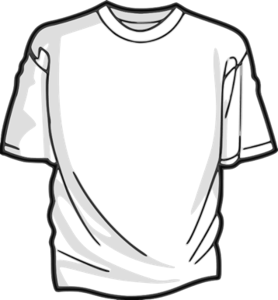
Caucasian/White | African American/Black
Hispanic/Latinx | Asian
American Indian/Native American | Bi-racial/Multi-Racial
Middle Eastern/North African

